Abstract

*Game Development is the art of creating games and describes the design, development and release of a game. It may involve concept generation, design, build, test and release. While you create a game, it is important to think about the game mechanics, rewards, player engagement and level design.*

Game development

Assignment 1

*September 25, 2019*

**Submitted To**  
*Shair Kashif*

**Submitted By**

*Usama Sarwar*

FA17-BS(CS)-090-B

# Question No. 01

What is Quality Assurance?

**Answer:** The preservation of a wanted level of excellence in a package or product, particularly using courtesy to every stage of the procedure of distribution or manufacture. Quality assurance is a way of avoiding mistakes and flaws in manufactured products and evading problems when distributing products or facilities to customers.

# Question No. 02

What is the role of Quality Assurance Engineer in industry?

**Answer:** Quality Assurance Engineers are answerable for measuring the quality of provisions and procedural enterprise leaflets to guarantee a timely, applicable and expressive response. They are involved in the preparation and executing tactics for quality supervision and testing.

# Question No. 3

Why we rate and comment on stores (play, iTunes & amp; amazon etc.)?

**Answer:** Rating is important because;

* It shows the real-time experience of previous users.
* Builds trust among new users.
* Rating is important to let new users know about the quality of product.
* It helps developer to improve the flaws of game.

# Question No. 4

Part 1: <https://play.google.com/store/apps/details?id=com.Draxters.SpaceFighterMetroidAttack>

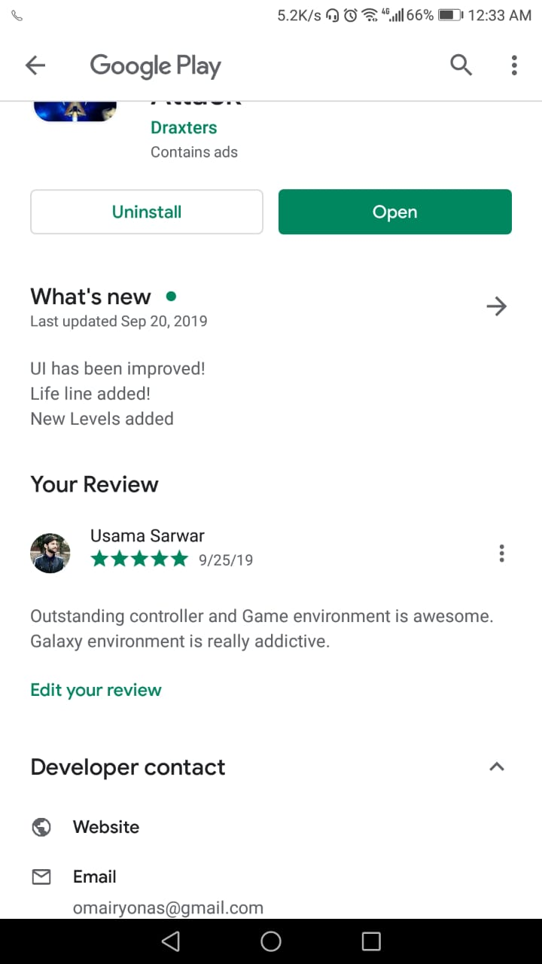

## **Part 2:**

**Quality Assurance Rules**

* Interactive Gameplay: **Yes**
* Addictive: **Average**
* Graphics: **HD**

**Graphics:** Average, some text in gameplay is not visible that shows a poor approach in graphics. i.e. in Gameplay.

**Gameplay:** Scenes and Backgrounds are attractive.

**Controls:** Excellent